
SRM Institute of Science and Technology
Mode of Exam
OFFLINE
SET A – B1

College of Engineering and Technology
School of Computing
DEPARTMENT OF COMPUTING TECHNOLOGIES
SRM Nagar, Kattankulathur – 603203, Chengalpattu District, Tamilnadu
Academic Year: 2022-2023 (ODD)
Test: CLAT-1 Date: 22.02.2023
Course Code & Title: 18CSC305J– Artificial Intelligence Duration: 9.45 am– 10.45 am
Year & Sem: III/VI Max. Marks: 25

Course Articulation Matrix:
CO | PO1 | PO2 | PO3 | PO4 | PO5 | PO6 | PO7 | PO8 | PO9 | PO10 | PO11 | PO12
CO1 | M | M | M | M | H | - | - | - | M | L | - | H
CO2 | M | H | H | H | H | - | - | - | M | L | - | H
CO3 | M | H | H | M | H | - | - | - | M | L | - | H
CO4 | M | H | M | H | H | - | - | - | M | L | - | H
CO5 | M | H | H | H | H | - | - | - | M | L | - | H
CO6 | L | H | M | M | H | - | - | - | H | L | - | H

Part - A
( 10 x 1 = Marks)
Instructions: Answer all
Q. No | Question | Marks | BL | CO | PO | PI Code
1 | Which is not an example of ill-structured problem  - Predicting how to dispose e-waste safely  - Security threats in social gatherings  - Network flow analysis problem  - Predicting how to throw the waste in the dustbin  Ans: c | 1 | 1 | 1 | 1 | 1.6.1
2 | State artificial intelligence  - Programming with your intelligence  - Feeding your intelligence into computers  - Game playing  - Enable computers to be intelligent  Ans: d | 1 | 1 | 1 | 1 | 1.6.1
3 | Select the field that investigates high level human/animal thinking  - Psychology and cognitive science  - Philosophy  - Neuroscience  - Linguistics  Ans: a) | 1 | 2 | 1 | 1 | 1.6.1
4 | _________ is used by the agent to act upon the environment  - Sensors  - Actuators  - Perceptors  - Motors  Ans: b) | 1 | 1 | 1 | 1 | 1.6.1
5 | Analyze the role of knowledge in playing chess  - To able to recognize solution  - To Constrain the search for a solution  - To able to recognize solution and to Constrain the search for a solution  - To reach the goal state with single path cost.  Ans: b | 1 | 2 | 1 | 1 | 1.6.1
6 | Identify the problem type which is very hard to formulate and ambiguous in nature.  - Structured  - Linear  - Unstructured  - Non- Linear  Ans: c | 1 | 2 | 1 | 1 | 1.6.1
7 | Solve the crypt arithmetic puzzle LET + LEE = ALL  - L=5, T=2, A=5, E=1  - T=5, A=2, L=1, E=4  - E=3, A=1, T=5, L=6  - L=1 ,E=5, T=6, A=3  Ans: d | 1 | 3 | 1 | 2 | 1.6.1
8 | Which type of agents does personal assistants like siri, Alexa belongs to  - Intelligent agents  - Simple reflex agents  - Model-based agent  - Problem-solving agent  Ans: a) | 1 | 2 | 1 | 2 | 1.6.1
9 | _________________ are mathematical problems defined as a set of objects whose state must satisfy a number of constraints or limitations.  a) Constraints Satisfaction Problems  b) Uninformed Search Problems  c) Local Search Problems  d) Component based problem  Ans: a) | 1 | 1 | 1 | 1 | 1.6.1
10 | Intelligent backtracking makes use of  a. Unassigned variables set to decide the values  b. A conflict set to backtrack to the source  c. Backjumping to detect the failure node  d. Heuristic to detect the failure  Ans: c | 1 | 1 | 1 | 1 | 1.6.1
Part – B
( 3 x 5 = Marks)
Instructions: Answer any 3
11 | Expand PEAS. Give PEAS description for online elective polling system.  PEAS stands for Performance measures, Environment, Actuators, and Sensors.  Performance measures: These are the parameters used to measure the performance of the agent. How well the agent is carrying out a particular assigned task.  Environment: It is the task environment of the agent. The agent interacts with its environment. It takes perceptual input from the environment and acts on the environment using actuators.  Actuators: These are the means of performing calculated actions on the environment. For a human agent; hands and legs are the actuators.  Sensors: These are the means of taking the input from the environment. For a human agent; ears, eyes, and nose are the sensors.  Performance measures:  Cost of the portal  Quality of the portal system  Time taken to poll  Environment:  Portal page components which has the details such as Time slot, Date, Day order, Lab venue etc.  Actuators:  Booking function, Pc, Mobile device  Sensors  Input and output device  Eyes | 5 | 3 | 1 | 2 | 1.6.1
12 | You are given two jugs, a 5-gallon one and a 3-gallon one, a pump which has unlimited water which you can use to fill the jug, and the ground on which water may be poured. Neither jug has any measuring markings on it. How can you get exactly 1 gallons of water in the 5-gallon jug?  Represent the solution with state space.  Solution:  initial state: (5,3)  goal state: (1,0)  operators:  i) empty big(remove water from big jug)  ii) empty small(remove water from small jug)  iii) big is empty(pour water from small jug to big jug)  iv) small is empty(pour water from big jug to small jug)  actions of sequence: 2,4,2,4,2 | 5 | 3 | 1 | 2 | 1.6.1
13 | Describe the utility based agent with example.  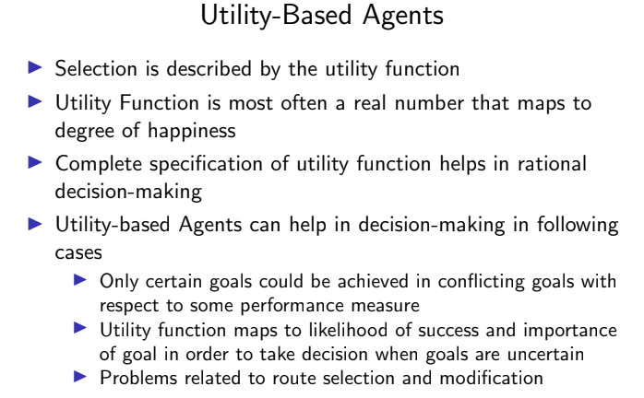  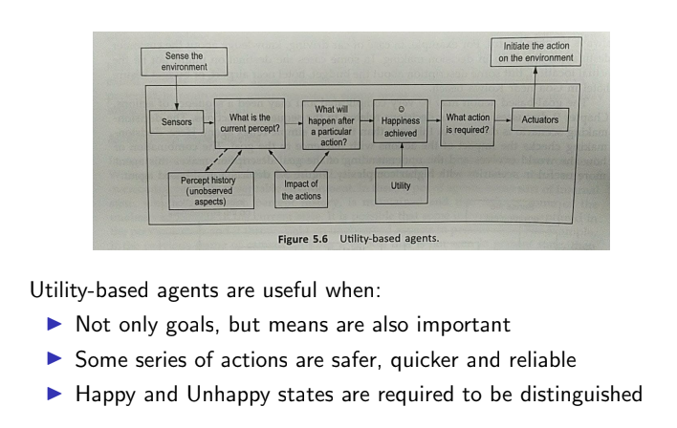 | 5 | 1 | 1 | 1 | 1.6.1
14 | Compare forward checking and constraint propagation.  Forward checking • Idea: – Keep track of remaining legal values for unassigned variables – Terminate search when any variable has no legal values  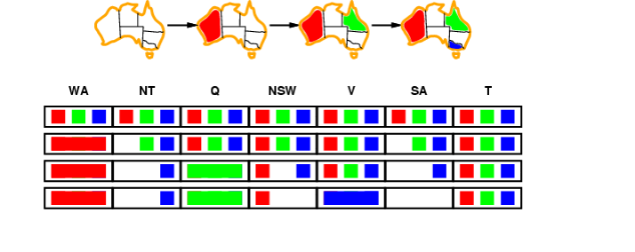  Constraint propagation  • Forward checking propagates information from assigned to unassigned variables, but doesn't provide early detection for all failures:  NT and SA cannot both be blue!  • Constraint propagation algorithms repeatedly enforce constraints locally…  Arc consistency • Simplest form of propagation makes each arc consistent • X → Y is consistent iff for every value x of X there is some allowed y  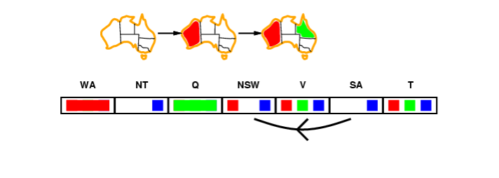 | 5 | 2 | 1 | 1 | 1.6.1

SRM Institute of Science and Technology
College of Engineering and Technology
Mode of Exam
OFFLINE
SET B – B1
School of Computing
DEPARTMENT OF COMPUTING TECHNOLOGIES
SRM Nagar, Kattankulathur – 603203, Chengalpattu District, Tamilnadu
Academic Year: 2022-2023 (ODD)
Test: CLAT-1 Date: 22.02.2023
Course Code & Title: 18CSC305J– Artificial Intelligence Duration: 9.45 am– 10.45 am
Year & Sem: III/V Max. Marks: 25

Course Articulation Matrix:
CO | PO1 | PO2 | PO3 | PO4 | PO5 | PO6 | PO7 | PO8 | PO9 | PO10 | PO11 | PO12
CO1 | M | M | M | M | H | - | - | - | M | L | - | H
CO2 | M | H | H | H | H | - | - | - | M | L | - | H
CO3 | M | H | H | M | H | - | - | - | M | L | - | H
CO4 | M | H | M | H | H | - | - | - | M | L | - | H
CO5 | M | H | H | H | H | - | - | - | M | L | - | H
CO6 | L | H | M | M | H | - | - | - | H | L | - | H

Part - A
( 10 x 1 = Marks)
Instructions: Answer all
Q. No | Question | Marks | BL | CO | PO | PI Code
1 | Which of the following is not a heuristic way?  - To discover something or an idea embedded in a program  - To search and measure how far a node in a search tree seems to be from a goal  - To compare two nodes in a search tree to see if one is better than the other is  - Exploring the state space without considering the cost of reaching the goal  Ans : d | 1 | 1 | 1 | 1 | 1.6.1
2 | The extraction of meaningful information that is previously unknown and can be very useful potential ahead is known as  - Knowledge Discovery  - Machine Learning  - Learning Theory  - Neural Computation | 1 | 1 | 1 | 1 | 1.6.1
3 | Which model is based on sign processes or signification and communication?  - Syntactic  - Semantic  - Semiotic  - Statistical | 1 | 2 | 1 | 1 | 1.6.1
4 | The process of removing detail from a given state representation is called  - Extraction  - Abstraction  - Information retrieval  - Mining of data | 1 | 1 | 1 | 1 | 1.6.1
5 | Choose the correct: A) knowledge base (KB) consists of a set of statements. B) Inference is deriving a new sentence from the KB.  - A is true, B is true  - A is false, B is false  - A is true, B is false  - A is false, B is true | 1 | 2 | 1 | 1 | 1.6.1
6 | Treatment given by doctor for a patient to treat a disease is based on  - Only current symptoms  - Current symptoms plus some knowledge from the textbooks  - Current symptoms plus some knowledge from the textbooks plus experience  - some knowledge from the textbooks plus experience | 1 | 2 | 1 | 1 | 1.6.1
7 | What happens when the backtracking calculation arrives at a solution?  - It backtracks to the root  - It continues searching for other possible solutions  - It traverses from a different route  - Recursively traverses through the same route | 1 | 1 | 1 | 2 | 1.6.1
8 | Which environment cannot be changed while the agent is deliberating?  - Static  - Stochastic  - internal state  - percept | 1 | 2 | 1 | 2 | 1.6.1
9 | The following diagram is the representation _________ in state space of 4 – queen’s problems.  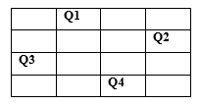  a) Initial state  b) Intermediate state  c) Goal State  d) Path | 1 | 2 | 1 | 1 | 1.6.1
10 | Constraints are the ones that restrict  - Movement  - Arrangement  - Possibilities  - Solutions  - 1,3  - 1,2,3,4  - 2,4  - 1,3,4 | 1 | 2 | 1 | 1 | 1.6.1
Part – B
( 3 x 5 = Marks)
Instructions: Answer any 3
11 | Discuss about the Problem Formulation for Vacuum Cleaner World.  Assume that the agent knows its location and the locations of all the pieces of dirt, and the suction is still in good working order.  • States: one of the eight states  • Operators: move left, move right, suck.  • Goal test: no dirt left in any square.  • Path cost: each action costs 1.  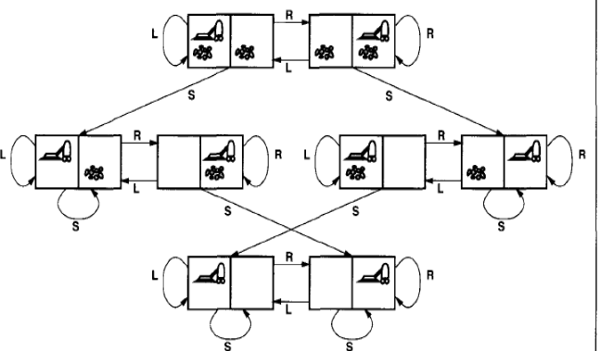 | 5 | 3 | 1 | 2 | 1.6.1
12 | Solve the following cryptoarithmetic puzzle  - EAT + THAT = APPLE (2.5 marks)  3 digit number (EAT) + 4 digit number(THAT) = 5 digit number(APPLE)  If so, then A can be 1 and p can be 0.  Again here T is yielding a two digit number (10).  So there must be a carry 1 and T = 9.  Now the expression becomes  E 1 9  9 H 1 9  -------------  1 0 0 L E  Now it is clear that E = 8 and L = 3  So,A + T + L = 1 + 9 + 3 =13  - TWO + TWO = FOUR (2.5 marks)  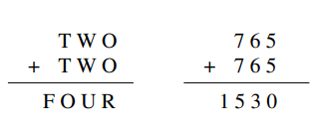 | 5 | 3 | 1 | 2 | 1.6.1
13 | Compare the Model based agent and goal based agent.  Model-based Reflex Agents (2.5 marks)  - Percept history is maintained (Using internal states)  - Agents reflect some of the unobserved aspects of the current state  - Incorporating things in determining the unobserved aspects is called model  - Model keeps track the past sequence of percept to determine the unseen part and impact of actions on environment  - Model-based intelligent agents have wide applications  compared to simple reflex agents  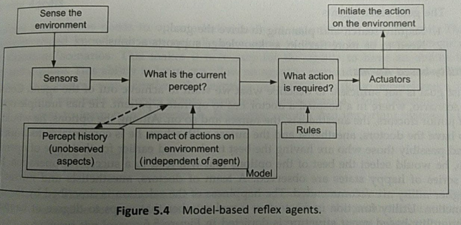  Goal based agent: (2.5 marks)  Goal of Decision-Making is considered  - Goal based action is very complicated and need a sequence of  - actions  - Decision-Making checks the impact of actions with reference  - to the goal  - Less efficient but more flexible  - More time is required for reasoning process  - Resemblance of Model-Based agents  - Goal based agents require  - Require search and planning to drive the goal  - Need to be more flexible, as knowledge supports action  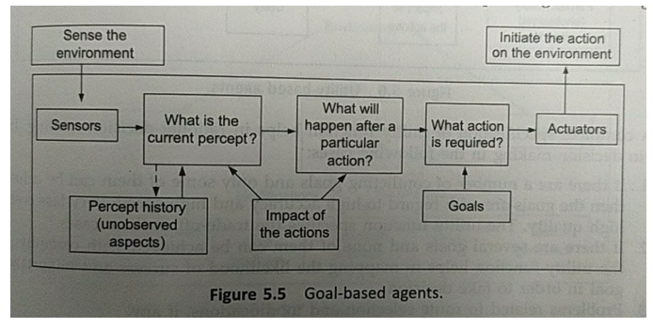 | 5 | 1 | 1 | 1 | 1.6.1
14 | Explain the concept of intelligent backtracking with example. (Explanation : 3 marks; Example : 2 marks)  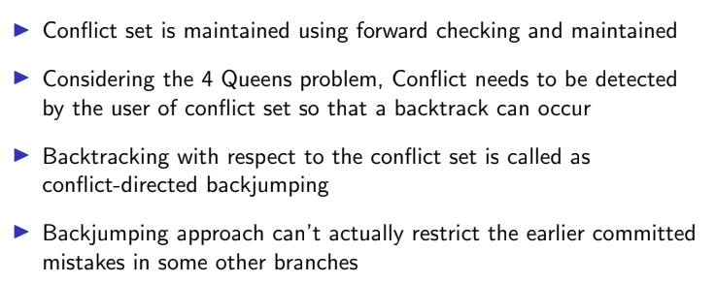 | 5 | 2 | 1 | 1 | 1.6.1

